May 29, 2016 / revision 1

#### Membership and Growth in Family Sized Congregations

Growth is more than just numbers.

Prepared by:

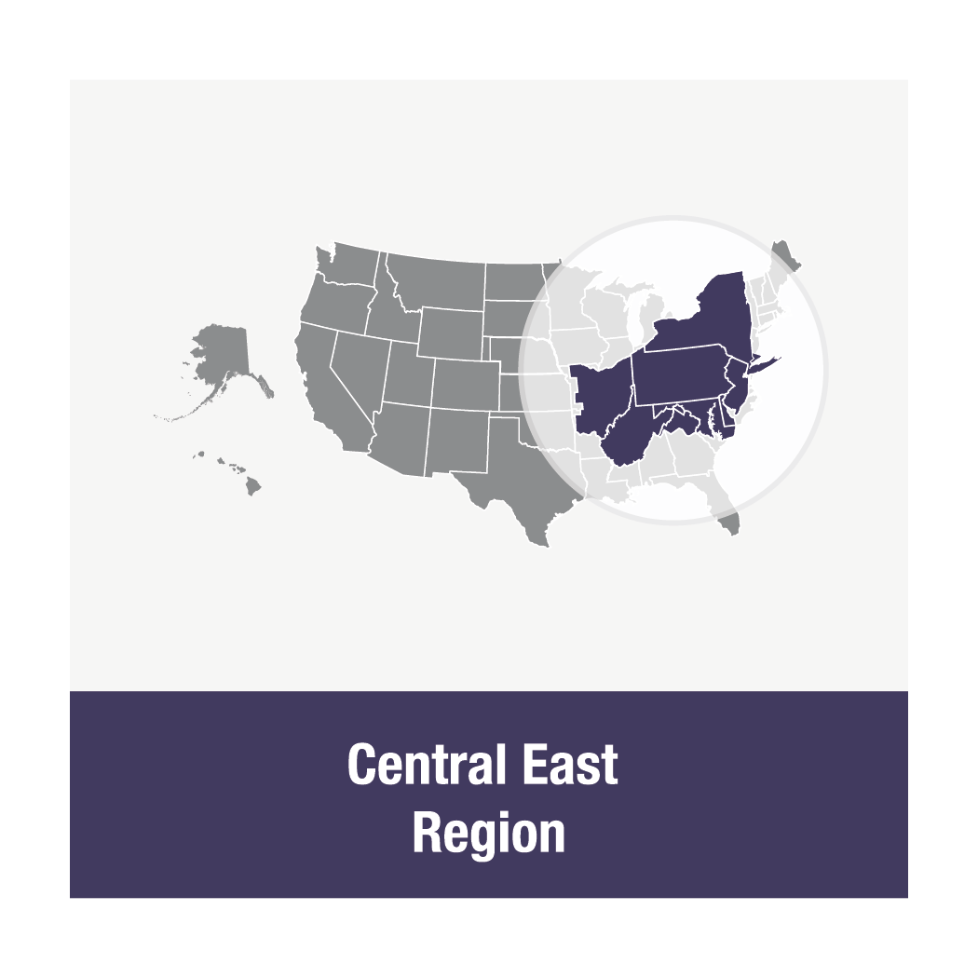

# Before you begin:

## You first want to ask yourselves, “Why do we want to grow?”

* What need is it in your community and in your neighbor’s lives that your congregation is ready to fill?
* Be sure to consider also the unchurched- why would someone who has never been to church before get out of their pajamas on a Sunday morning? How can you teach those people what church can do for them?
* In general, orient towards what your congregation is offering to newcomers - not what you’re hoping they’ll do for you.
* Hint: “All our leaders are burned out and need a break,” or “We sure need more money to stay open,” are not the answers you are looking for here.

You then want to ask yourselves, **“Is our congregation healthy?”**

* If your congregation is struggling with conflict or grief, those issues need your attention before a major growth initiative. Just as you would rather go on a first date with someone who feels healthy and satisfied with their life than someone who has the flu or is still grieving the loss of their ex-partner.
* If you think you might have some issues of congregational health to consider, contact your [Regional Primary Contact](https://uua.wufoo.com/forms/m19xyk360tbevj0/) person. Another excellent resource is Peter Steinke’s book [***Congregational Leadership in Anxious Times***](https://books.google.com/books?id=JflYAwAAQBAJ&lpg=PA3&dq=congregational%20leadership%20in%20anxious%20times&pg=PA3#v=onepage&q=congregational%20leadership%20in%20anxious%20times&f=false) or the online course offered by the UU Leadership Institute on **Healthy Leadership**. (Find out more at [www.uuinstitute.org](http://www.uuinstitute.org) )
* It might also be helpful to review the types of growth that lead to numerical growth. See Appendix A for more details.

**Now you are ready to think about Membership and Growth.**

Family size churches need to use their resources in a mindful, focused way. When reviewing the list below, don’t try to do all these things at once. Pick one or two that you think would be doable and useful in your community. Implement those and make them a congregational “habit” before adding other actions or programs.

**A Comprehensive Membership Journey Includes 5 parts:**

1. **Awareness of and Interest in the Congregation.** 
   1. 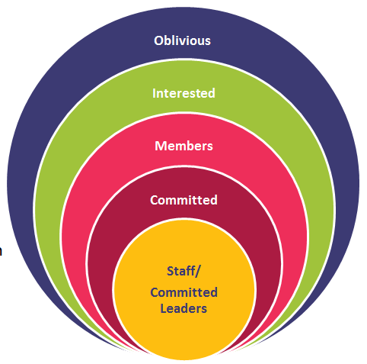Identify and articulate your congregation’s unique offering to your community. Try to mention it in all of your communications.
   2. A website that is user friendly and up to date. (The UUA offers a [UU branded template](http://www.uua.org/communications/websites/wordpress-theme) on a WordPress platform.)
   3. Regular press releases to local papers.
   4. Regular posting on Facebook and other social media.
   5. A sign on your church that is visible from the road
2. **How do you interact with first time guests?** 
   1. Are there any obvious pitfalls to your welcome? (You may wish to ask some members from neighboring UU churches to observe you.)
   2. Think of visitors as your house guests that you want to feel welcome and appreciated.
   3. Is your worship space and social hall tidy?
   4. Does your building smell pleasant? (At the same time, avoid masking odors with heavily scented air fresheners that might trigger the allergies of visitors.)
   5. Make sure the entrance to your meeting space is clearly marked, especially if you are in a rented space, or if visitors need to enter through a side door.
   6. Are you friendly? Do you make visitors feel comfortable? You don’t want them to feel “on display” but you do want them to feel a little bit special.
   7. All guests should be greeted at the entrance by a gentle, friendly greeter who can invite them in and answer their questions.
   8. Explicitly introduce or connect a visitor to someone in their demographic or with similar interests - parents of young kids with others, young adults with others, someone who is there "to help make the world better" with the social justice team, etc.
   9. Does anyone in your congregation “creep people out” with disruptive behavior or squishy personal boundaries?
   10. Encourage guests to leave their e-mail or other contact information so they can be added to the newsletter list. (NEVER put visitors on a listserv or email list meant for members only.)
   11. Is it easy to figure out how things work on Sunday morning, e.g. when to sit and stand, where to get coffee, where the bathrooms are?
   12. If someone was learning about you by looking at what’s on your walls, what would they learn? *[Examples: Offensive messaging, like “NEVER touch this thermostat”, new member photos of people who are no longer members, etc.]*
   13. Follow up with first time guests with a handwritten note or personalized e-mail or Facebook message.
3. **How Do You Interact with Repeat Guests So That They Consider becoming Members?**
   1. How do you get visitors to visit a second and third time?
      1. Say, “We hope to see you next week!” when they depart and in your follow-up note or email.
      2. Personally invite them to an upcoming social event.
      3. Have regular potlucks after the service, and invite them to be the congregation’s guest, i.e. they aren’t expected to bring a dish.
      4. Make sure your newsletter and other church communication is easy for outsiders to understand, e.g.“Call Martha Stewart at 555-555-5555 to find out more” helps newcomers connect, where “call Martha to find out more” makes newer folks feel left out.
      5. Avoid insider language, such as acronyms, e.g. “The UUWF is selling baked goods to send the CoA group to the UUA’s GA.”
   2. What opportunities do you have to help newcomers become more connected, more integrated?
      1. Offer a newcomer orientation, and serve snacks!
      2. Encourage repeat visitors to consider a smaller job, like greeting or making coffee.
      3. Think about creating a program that you can steer them towards. Small groups? Potluck dinners?
      4. DO NOT suggest that they “join the board.”
   3. Is there a clear process to becoming a member?
      1. Do you have a brochure or half-sheet spelling out your path to membership?
      2. Do you refer to the membership brochure during your announcements?
      3. Are repeat visitors invited to join?
      4. Are the steps made clear to potential members (including how to pledge)?
      5. Is there a new member ritual or celebration?
4. **How Do You Help New Members Become Committed, Active Members?**
   1. “Membership” is a changing concept in this day and age. Many young adults take commitment seriously and may not want to sign a membership book too quickly. Do you offer ways people get involved in your congregation, to donate money, without having to become an official “member”?
   2. Existing leaders usually think about the responsibilities attached to more active involvement. Are there also rewards? Be sure to include those in your membership materials.
   3. Are there regular social events? Part of a healthy congregation attractive and sustaining to members is having fun together.
   4. Are there programs to deepen the spiritual/religious lives of members and other involved people over time?
   5. Reach out to members whom you haven’t seen in a while. A call or note to show you are thinking of them is often appreciated.
   6. Are there housebound members who are unable to come to services? How can you reach out to members who aren’t able to be with you in person?
5. **Do You Provide an Opportunity for People to “Depart Well?”**
   1. When someone departs the church, whether moving for their job, by fading away, or leaving during a conflict, follow up with an exit interview to gather some insight about their experience of your congregation (See Appendix B).

## Appendix A: Five Types of Growth

1. **Organic Growth -** The task of building the community, fashioning the organizational structures, developing the practices and processes that result in a dependable, stable network of human relationships in which we can grow and from which we can make a difference. It is also the physical plant and the staff needed for the size of the congregation.
2. **Maturational Growth -** The ability of a congregation to challenge, support and encourage each one of its members to grow in the maturity of their faith, to deepen their spiritual roots, and to broaden their religious imagination. It is also the ability of the congregation as an institution to go deeper into the faith while maintaining the welcoming path for newcomers.
3. **Incarnational Growth** - What are the “outputs” of the congregation’s ministry? What is it that the congregation seeks to export from its life back into the life of the world, the social environment in which it exists? What are the good works that we are doing that will make the world a better place?
4. **Growing in Connections**- Growing awareness of the importance and relevance of connections, e.g. involvement in cluster, district, regional, and national activities related to the UUA and other connections.
5. C:\Users\Van Becelaere\AppData\Local\Microsoft\Windows\Temporary Internet Files\Content.IE5\MHJLV19P\MC900287134[1].wmf**Numerical Growth -** Adding new members while maintaining the number of members already within the congregation. Keeping track of losses and understanding why they happen. Changing the things that need to be changed in order to retain healthy members. Never compromising ethics or principals. Understanding that some losses are healthy or inevitable.

## Appendix B: Sample Exit Interview

When a congregant decides to end his/her membership with *[your congregation’s name]*, the following questions can be asked of him/her in an interview, either in person or by telephone.  The interview can be conducted by a member of the Board of Trustees, a member of the Committee on Ministry, a member of the Membership Committee or any other body as directed by the Board of Trustees.  Over time, as information is gleaned from these interviews, it is hoped that *[your congregation’s name]*will have increased success in retaining and serving its members.

**Example opening:**  “I’m calling as a representative of the Committee on Ministry (or whichever group you represent).  We are trying to better understand why members have left *[your congregation’s name].* Would you have a few minutes to answer a few short questions?

**No:** Would there be a better time? (And then schedule.)

**Yes:** Thank you. I know your time is valuable. I really appreciate your willingness to do this.

* What attracted you to *[your congregation’s name]*?
* Why did you decide to join?
* Did you initially feel welcome at *[your congregation’s name]*?
  + YES_____Could you share an example?
  + NO_____ I’m so sorry to hear that. Would you like to talk about it?
* Did you feel a part of the *[your congregation’s name]* community during your time at the church?
  + YES_______ Could you share an example?
  + NO______ I’m so sorry to hear that. Would you like to talk about it?
* Why did you decide to leave *[your congregation’s name]*?
  + (Probe) What else?
* Was there anything else that disappointed you about *[your congregation’s name]*?
* Have you found another church home yet?
  + YES____Which one? NO____(no follow-up)
* In thinking back, how could we have responded to your needs better?
* Is there anything else we should know to help make *[your congregation’s name]* more responsive to people?
* Would you recommend *[your congregation’s name]*to a friend or family member?
  + YES_____ What would you tell them about us?
  + NO_____ What has given you pause about us?
* If it feels right, ask the person about how life is going for them, expressing curiosity and care.
* Thank the person for their time, then end the call.